Traffic Sign Classification using CNN(Live)

# Dataset

We are using German Traffic Sign Dataset with 43 classes

# Setting up the Parameters

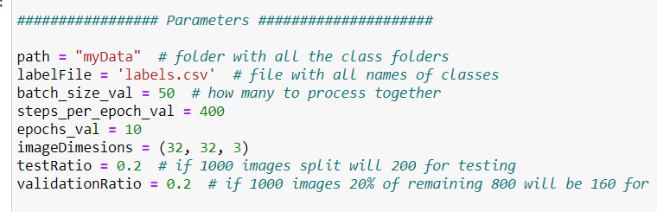

Importing Images

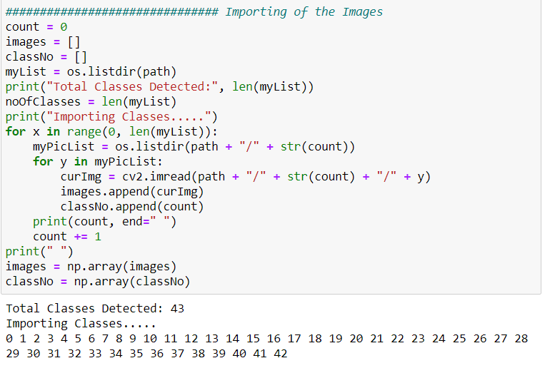

# Split our Data into Train and Test Dataset

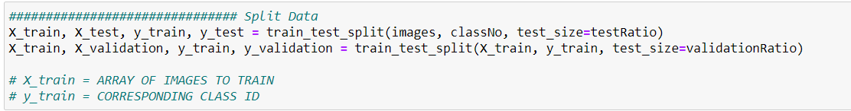

# Reading the CSV File

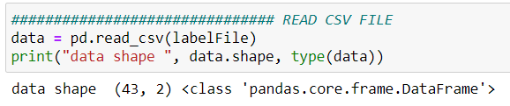

# Display Some Of the Images

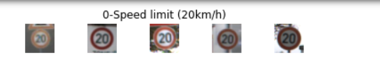

# DISPLAY A BAR CHART SHOWING NO OF SAMPLES FOR EACH CATEGORY

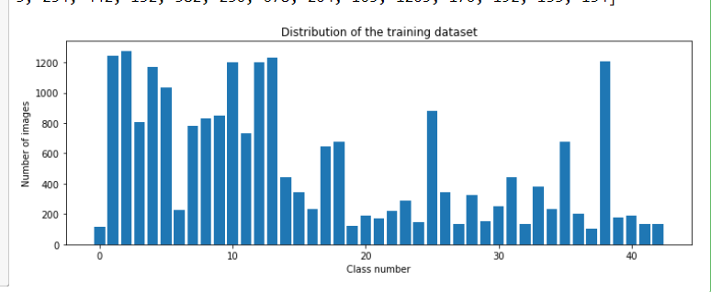

# Our Model

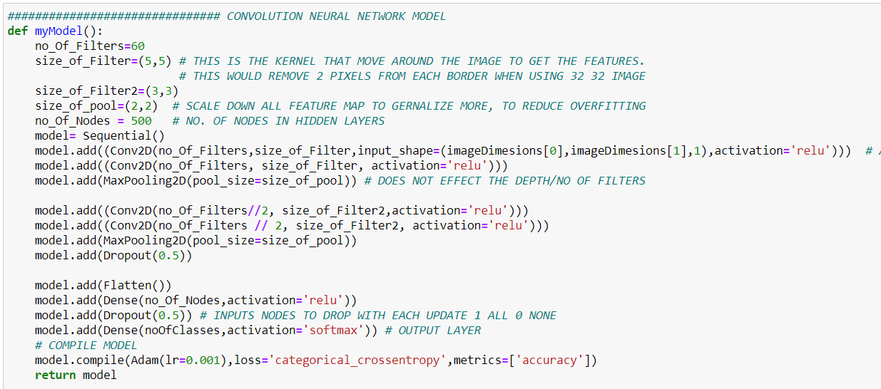

# Train our Model

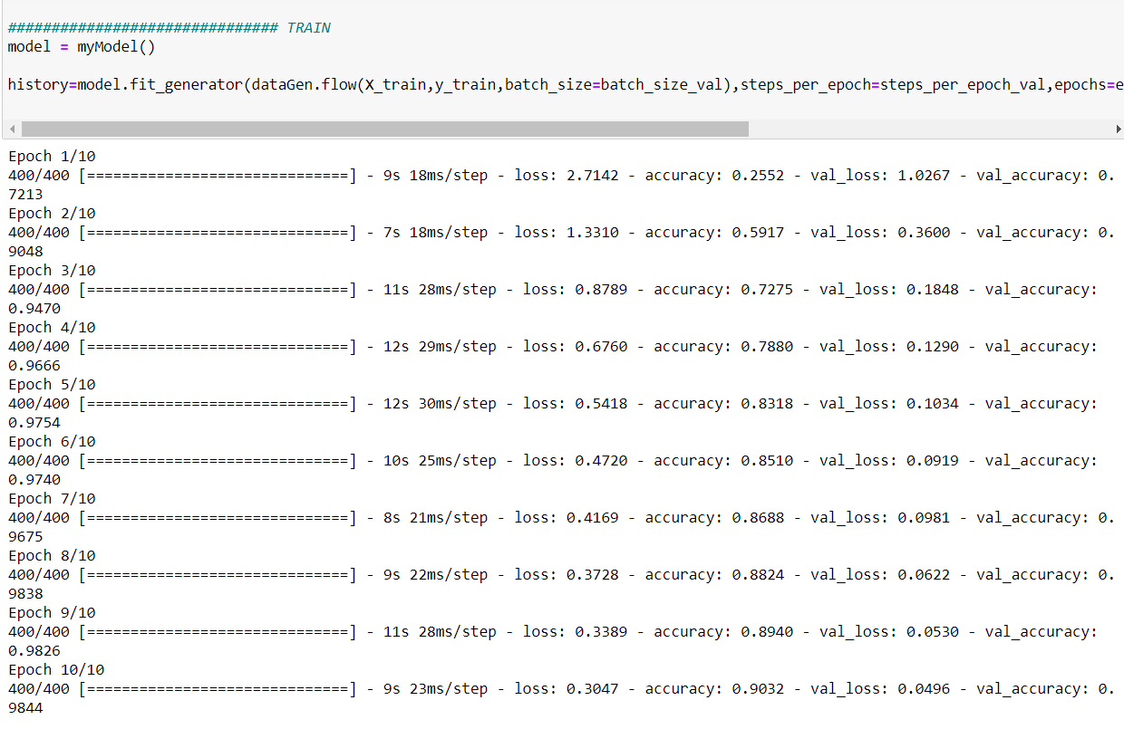

# Plot (Loss vs Accuracy)

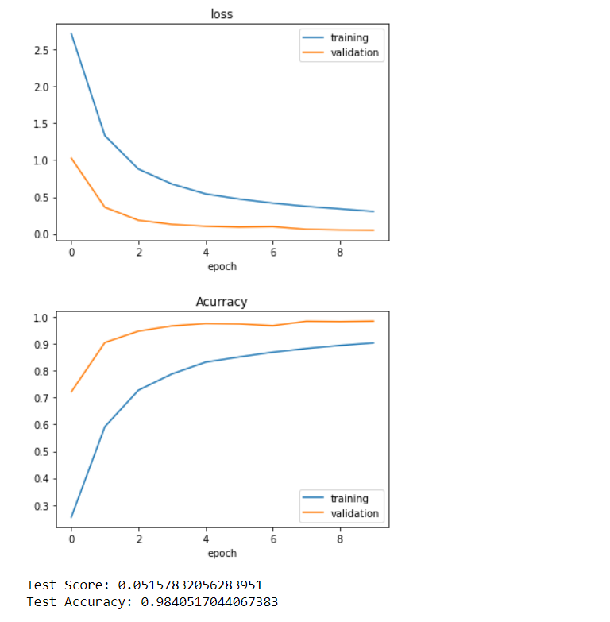

Testing on Live Camera(Real Time)

# Setting up the Parameters

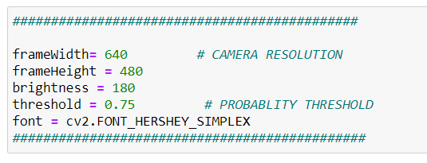

# Setup the Video Camera

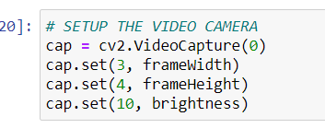

# While loop to Give us Continuous Image

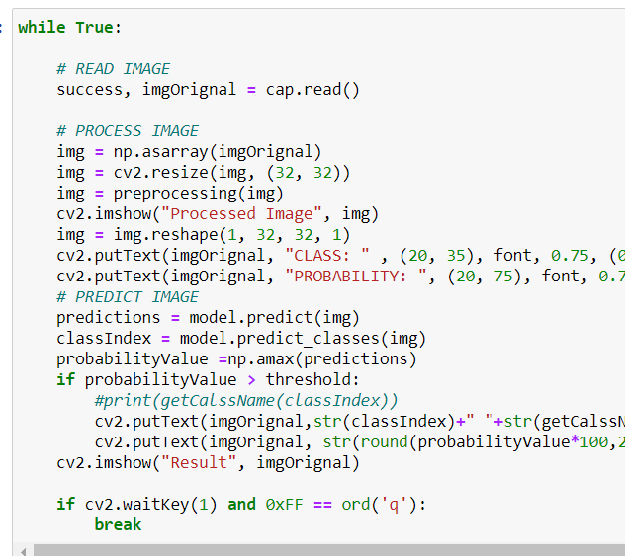

# Result (Realtime)

